Speaking of Scams…
Every day, scammers target people in our communities. Some scams reach a wide audience, others focus on certain groups – for example, older adults or Spanish-speakers. But you can make a difference by talking to people you know. Share the scams you hear about. A few words from you can help someone you care about avoid scams.
What can you tell people about scams? Here’s a start:

Check it out.
Someone might ask you for money or personal information. But do you really know who’s behind that email or on the phone? They might not be who they say they are. Check it out before you do anything. Talk to someone you know about how you can confirm the story – and what you should do.

Don’t be in a hurry.
Someone might want you to act now to give them money or personal information – before you have time to think about it. Tell that person you need time. Then talk to someone you trust before you do anything else.

Talk about it.
The best way to avoid a scam is to talk about it – even if you’re not sure it is a scam. Talking about the phone calls and emails you get can help you, and helps those you care about.

Report scams.
If you spot a scam, tell us. Your report makes a difference. Report scams in English and Spanish: call 1-877-382-4357 or visit ftc.gov/complaint (English) or www.ftc.gov/queja (Spanish).
Want to learn more about scams? Visit consumer.ftc.gov.
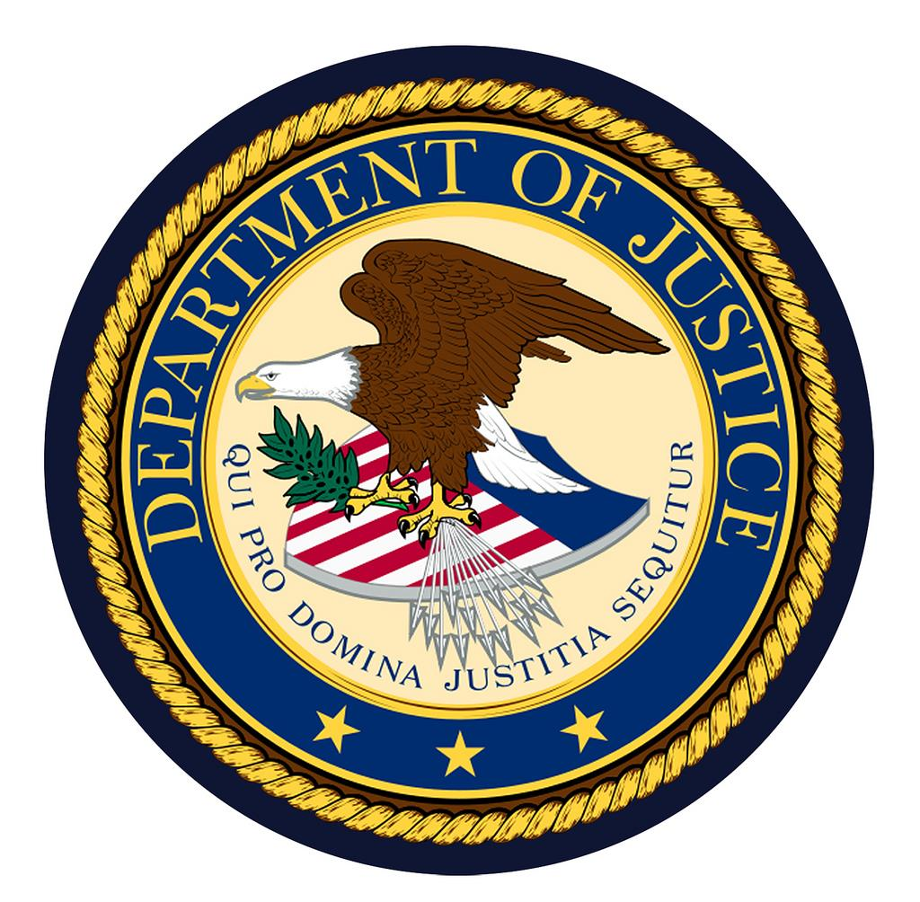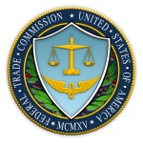
U.S. Department of Justice | Federal Trade Commission

